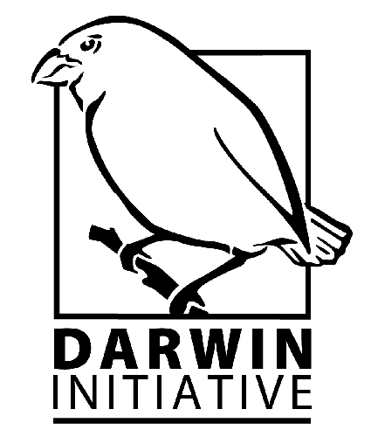

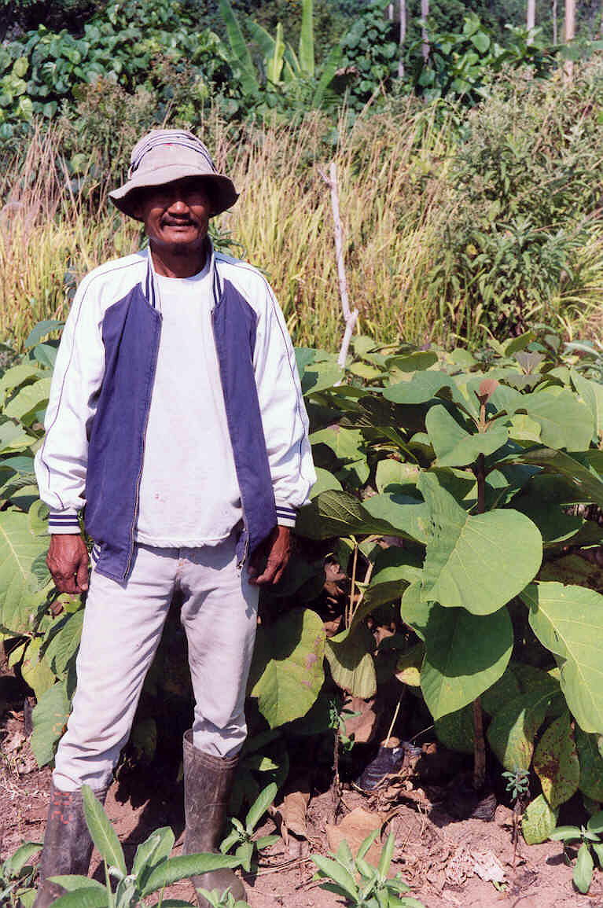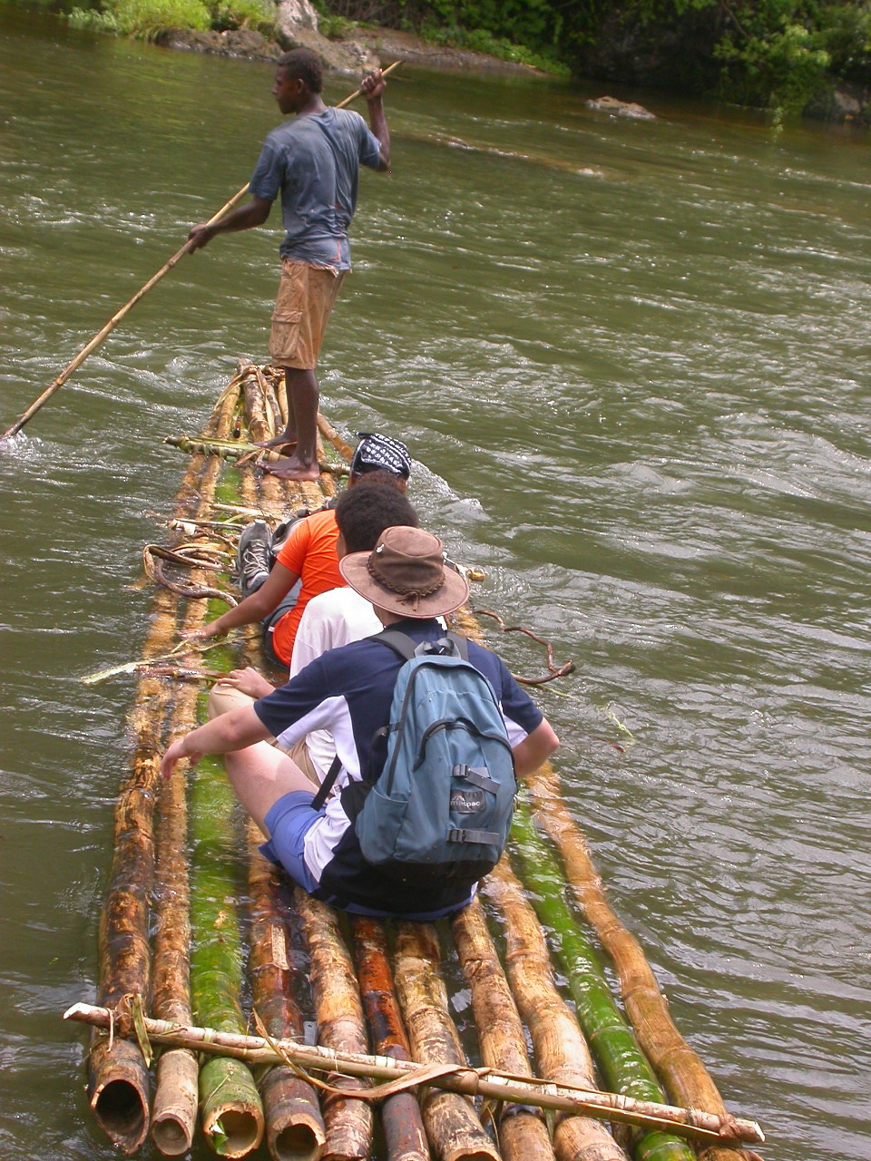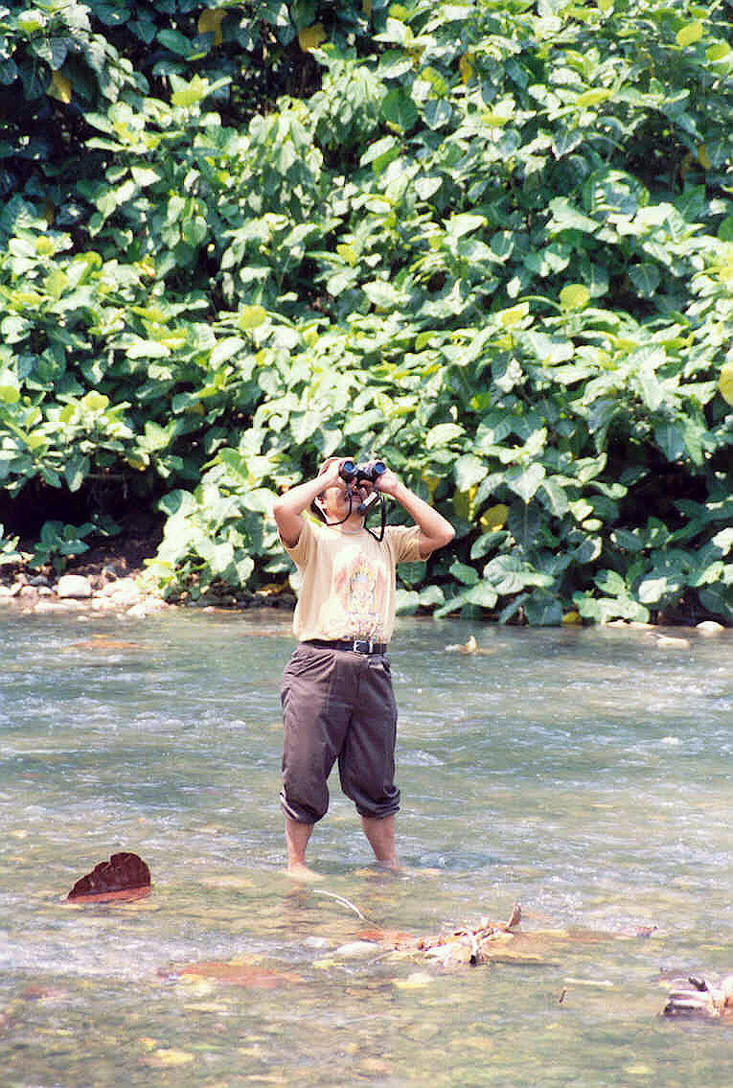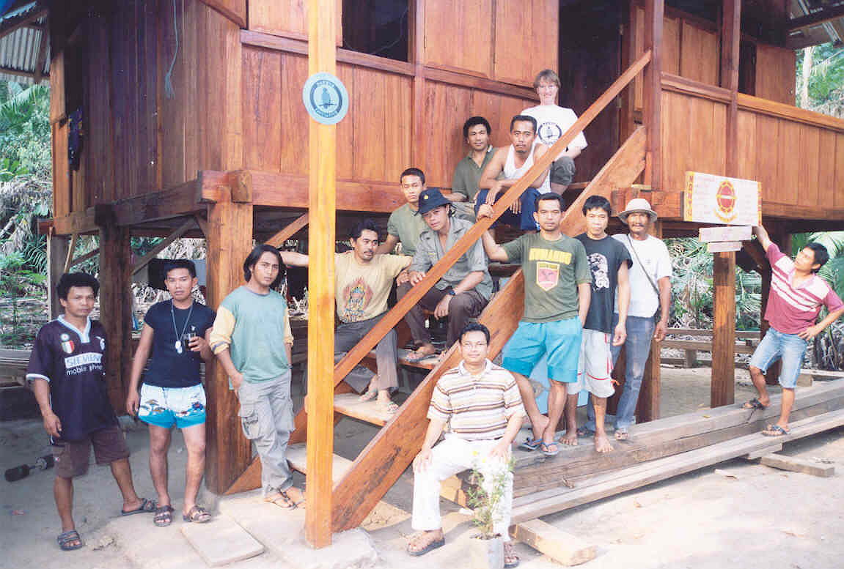
_____________________________________________________
Darwin Initiative Workshop

6th April 2005

Quality Hotel, London

Proceedings

TABLE OF CONTENTS

Introduction 1
Session 1 - ‘UK and Host Country Institutional Partnerships – Issues and Best Practices Emerging from Darwin Initiative Projects’ 2
Seminar 2: Engaging community partnerships for biodiversity conservation – challenges and lessons’ 3
Seminar 3: ‘Disengaging from Darwin Initiative Funding – Challenges and lessons from exit strategies’ 7
Seminar 4: Taxonomy and monitoring of species: building capacity to support CBD information needs 9
Conclusions and Next Steps - Engaging in dialogue: Are Expectations from DI Projects Being Met? 13
List of Participants 14

Introduction

The Darwin Initiative Workshop took place on the 6th of April 2005, in London. It was a discussion forum for UK and Host country project leaders which provided an opportunity for Darwin UK and Host country partners to meet and share experiences and observations from their Darwin projects around some important themes. The plenary session was chaired by Professor David McDonald, Chairman of the Darwin Advisory Committee. It was informed by two presentations that addressed the lessons, challenges and best practice arising from DI project partnerships.

The first plenary presentation was given by Dr. Colin Pendry, from the Royal Botanical Gardens in Edinburgh (RBGE). It was followed by Dr. Helida Oyieke’s, from the National Museums of Kenya (NMK). Dr Pendry elaborated on his experience at trying to improve Nepal’s botanical skills by building the capacity of 18 staff within local institutions.

In turn, Dr. Oyieke gave an overview of the National Museum of Kenya’s modus operandi in terms of successfully establishing partnerships, by describing the challenges and lessons learnt from her experience with four ongoing and completed Darwin Initiative projects. This presentation gave a valuable perspective on the experiences from a host country point of view and on particular issues and constraints faced by Host Country participants.

The Minister for Environment and Agri-Environment, Hon. Elliot Morley welcomed Professor David Macdonald, to his new post as Chair of the Darwin Advisory Committee.

In a speech that addressed the increasing global recognition of the importance of Biodiversity to human well-being and livelihoods. The Minister outlined the significance of Darwin Projects to furthering collaboration between UK and host country institutions. He also highlighted the extensive portfolio of grants that the Darwin Initiative has awarded during the last twelve years.

The Minister showed great enthusiasm on the success of Darwin Initiative and commented on the privilege to hear and learn from those working on Darwin Initiative projects on the ground - but especially to hear the perspective of host country participants, as they are essential in taking forward the legacy of Darwin Initiative projects. The Minister stated that he has witnessed their enthusiasm and strong commitment first hand as he has visited a number of Darwin Initiative projects, including some in Kenya. After the Minister’s remarks the participants had an opportunity to network over lunch.

The afternoon session, which was chaired by Dr. Paul Van Gardingen from the University of Edinburgh, consisted of three successive plenary presentations which were followed by three simultaneous group discussions on each theme.
- Challenges and lessons from engaging community partnerships for biodiversity conservation;
- Disengaging from Darwin Initiative Funding: challenges and lessons from exit strategies;
- Taxonomy and monitoring of species: building capacity to support CBD information needs.

The following sections summarises critical issues raised during the plenary and group discussions. For additional information please refer to the presentations, which are available from Darwin Initiative Website http://www.darwin.gov.uk/events

Session 1 - ‘UK and Host Country Institutional Partnerships – Issues and Best Practices Emerging from Darwin Initiative Projects’

The RBGE is currently leading a project titled ‘Building Capacity for Plant Biodiversity Inventory and Conservation in Nepal’ in collaboration with the Royal Nepal Academy of Science and Technology (RONAST). This project aims at developing the capacity of 18 Nepalese scientists in data recording, plant collection, and conservation status assessment through continued training in both Nepal and the UK.

Dr. Pendry’s presentation focused on the ethical, as well as pragmatic, issues that are of importance when establishing and developing a partnership with a Host Country Institution. These can be summarised as follows:
- When establishing a partnership it is vital to develop a strong relationship of trust with Host country institutions. Some of RBGE’s recommendations for best practice include, among others: being clear at initial meetings (i.e. establishing roles and activities set against targets), keeping the team informed at all times to avoid miscommunication (i.e. copy everybody into group emails), maintaining personal relationships, meeting face to face with partners, and considering partner’s financial limitations when organizing meetings and workshops (i.e. by allocating travel bursaries).
- Inter-institutional Collaboration: Involving Government agencies raises the profile of projects and smoothes its development.
- Communication and resources: Project leaders need to be aware that there may be technical complications in Host countries, such as poor broadband internet links, library infrastructure, and obsolete or broken equipment.
- Limited budget: due to financial constraints some institutions have poor access to information, for example shipping loans may be expensive or there may be no money for staff to visit foreign herbaria. An initial assessment of information needs and processes to access it is a good first step.
- Other British institutions such as the British Council and British Embassies may be able to guide and provide resources to project leaders. Therefore, it is worth keeping these institutions up to date on the aims of DI projects.
- Carrying own equipment is key to facilitate meetings and consultations (i.e. data projector and other portable equipment).
Dr Helida Oyieke, Director of the National Museums of Kenya (NMK), illustrated her experience with four DI projects in which the NMK has collaborated with UK partner organisations, these follow:
- ‘Action plans for conservation of globally threatened birds in Africa’; (follow up project to DI 10-019) ran by the Royal Society for the Protection of Birds (RSPB);
- ‘Monitoring biodiversity for site management planning in eastern African wetlands’ (DI 11-002) run by the Wildfowl and Wetland Trust (WWT);
- ‘Kenyan Important Biodiversity Areas: Improving monitoring, management and conservation action’ (DI 11-003), run by RSPB;
- ‘Flamingo conservation and Ramsar site management at Lake Bogoria’, Kenya (DI 12-003), run by the Earthwatch Institute and the University of Leicester.
With a view of identifying best practices for developing real partnerships and maximising the impact of projects (and avoiding duplication of efforts), the following recommendations were set forward:
  - Look into improving in-country linkages;
  - Set simple systems in place for information and resource sharing between the organisations involved;
  - Likewise, build these systems into exit strategies for the projects;
  - Always look into fulfilling local needs; projects may evolve provided there is ownership and institutional support.

Seminar 2: Engaging community partnerships for biodiversity conservation – challenges and lessons’

Presentation by Mr. Solomon Mwangi
Nature Kenya

Discussion Facilitated by Mr. Paul Buckley
Royal Society for the Protection of Birds

During the first part of the presentation, Solomon Mwangi recounted his experience as leader of ‘Kenyan Important Biodiversity Areas: Improving Monitoring, Management and Conservation Action’ a Darwin Initiative project set up in partnership by RSBP and NatureKenya in 2002.

This project seeks to improve monitoring, management and conservation action taking place in areas with important biodiversity value. It guides conservation action by monitoring species and building capacity and skills of partners. The project helped to further develop partnerships at both the National Government and local community levels.

Reflecting on his experience, Solomon outlined the advantages of building partnerships with local communities. These include getting a better understanding of key biodiversity sites and their history, as well as learning to use traditional management systems.

Within this project, local partnerships are organized through ‘site support groups’. As Nature Kenya has learnt, site support groups function at their best when the local component of the project aims at satisfying a need felt by the community, in which case the community may desire to be part of a solution. Therefore these SSGs have the potential to be a nucleus and agent of change, and to spark a multiplier effect.

When setting up site support groups, Nature Kenya trains their partners in ornithological skills and needs assessments. It also facilitates the formalisation of a group structure by identifying leaders. Doing a skills and needs assessment is crucial at the start up of projects.

The second part of Mwangi’s presentation focused on the lessons learnt from community projects. These are outlined in the box below.

Institutional challenges identified by Nature Kenya and RSPB
- Institutions need to plan their growth according to their success;
- Partners’ expectations ought to be managed;
- Volunteer work is not always understood;
- There is a fine line between advising partners and trying to control them;
- Ownership of the project is key.

Nature Kenya’s Recommendations
- Feedback helps to keep continued interest and to develop ownership of the project;
- The monitoring methodology has to be open to be redesigned;
- Partnerships need to be looked after, with follow up support and mentoring;
- Projects should be designed to be simple and focused;
- Leaders should be identified;
- Avoiding quick fixes and going the hard way ensures sustainability;
- Group dynamics ought to be monitored.

Discussion Group

The group focused on building on Solomon’s presentation by discussing the experiences of other UK and Kenyan host country project leaders as well as Darwin scholars from Cuba, Galapagos Island, and Colombia. The seminar was to a great extent a forum to share reflections on project leaders’ Host country (and field) experience.

The discussion started out with the premise that community partnerships are key to the development of Darwin Initiative projects. The main focus was on answering the questions outlined in the box below, which led on to discussing participants’ views on how to develop best practice.

Q: How can Darwin Projects facilitate community involvement?

Q: What are the best ways to maintain UK and host country partnerships?

Q: What are the challenges we face?

Q: Considering the above, which best practice recommendations could arise?

The issues that were considered to be the most important after the brainstorm session are outlined below in order of importance:
- DI project leaders ought to involve stakeholders in the development and running of DI projects. It was pointed out that it is best to involve communities in decisions at all stages. Furthermore, fostering good relations with Government Agencies eases the pavement and will facilitate access to information and resources.
- Identifying key local leaders to partner with is a critical decision. Participants from developing countries pointed out that it is important to tap into local knowledge, prior to choosing a partner.
- Participation with local partners is not easy. Project Leaders ought to be realistic with the expectations and demands they place on local partners.
- To achieve better outcomes, it is crucial that Communities take ownership of resources and ideas. If the DI project satisfies community needs, it may foster the development of other ‘add on’ projects.
- Seek real empowerment not window dressing. Having strong partners furthers the success of the project and supports ownership. It also creates a firm basis for creating and up-scaling networks, which may be trans-boundary.
- Be democratic and look into engaging ALL sectors. This may be feasible by using existing village structures, even political ones if appropriate.
- Use local knowledge both as criteria for choosing partners but also to smooth communication and project coordination.
- Project partners could view at the potential of up-scaling partnerships and networks of communities on an ongoing basis.
- Acknowledge and seek to address long term funding needs by looking into creating opportunities to achieve financial sustainability of projects. The continuation and sustainability of a project ought to be addressed as part of the exit strategy. The exit strategy could be outlined as early as the project design.
- Do not hurry through the establishment of partnerships. Choosing project leaders is a critical step, and the success of the project depends greatly on this decision.
- DI projects ought to Catalyse and ensure better livelihoods.
- Try to secure long term funds, through different community enterprises such as ecotourism.

Session Conclusions and Recommendations

Further to the points raised above, participants reached the following conclusions:
- Partnerships take different forms. It is possible to link National Government Agencies, NGOs and communities under an umbrella partnership. This method increases the chances to upscale projects, and to strengthen networks and social capital.
- It is important to be open to design and redesign projects on an ongoing basis. This involves having a monitoring strategy that is embedded in the ‘culture’ of the partnerships with local communities.
- Project leaders should seek to advice rather than control. As the partner that has most of the finance, project leaders should be careful on how to stir host country partners’ input into projects. Likewise, it is advised that Project leaders are open to understand and learn from local ‘know how’. This is likely to facilitate the smooth running of the project.
- Fostering good group dynamics is key to the success of the project. Project leaders have to place emphasis on informing community partners about adjustments, particularly if they are budgetary, to ensure relations of trust.
- It is critical to create systems that ensure the sustainability of projects. These systems can be compatible with existing Government strategies. Awareness of local political issues and engagement of all sectors is crucial.
- Partnership models that work in the UK may not be at all compatible with local political systems and operational practices. Expectations of project leaders should be realistic in order to avoid frustration, and ineffective engagement of partners.

Seminar 3: ‘Disengaging from Darwin Initiative Funding – Challenges and lessons from exit strategies’

Presentation by Dr. James Hindson
Field Studies Council

Discussion Facilitated by Dr Paul van Gardingen
University of Edinburgh

Dr. James Hindson from the Field Studies Council (FSC) addressed sustainability and exit strategies by recounting his experiences from four Darwin Initiative funded projects, a couple of which have been completed. The FSC is an organization that specialises on training for projects such as introducing biodiversity education to communities in North East India. One of its goals is to address global environmental degradation by raising environmental awareness through education.

Discussion

The purpose of the session was to look at how projects work towards post Darwin continuity, and to draw out best practice and essential steps within an exit strategy. The questions were put to the group to initiate discussion included:

Q: What is a good exit strategy?

Q: What are the key elements of good practice which should be addressed when completing a Darwin project?

Q: Should all Darwin projects seek to have an exit strategy? If so, at which stage should it be outlined?

Q: How can Project Leaders facilitate post-Darwin continuation of projects; i.e. fundraising in the UK and host countries, up-scaling partnerships?

Q: What are the key steps in setting up efficient monitoring and evaluation systems for Darwin projects?

Q: Case studies: what and how can we learn from DI projects that have had both successful and tricky exit strategies?

As part of the seminar, the following points were raised:
- The first question to be addressed was whether projects require an exit strategy. Participants agreed that there are hardly any types of projects where no exit strategy would be needed;
- Whilst some were uncomfortable with the terminology there was strong agreement on principles that there needs to be an honest discussion between partners on the way that their partnership will change during and after the project as part of a longer term vision. The most important aspect of the exit strategy is to ensure local ownership of processes and products;
- Good project design will encapsulate the nature of the change by planning for continuity, legacy and impact. Southern participants stressed that it is important that Darwin projects deliver realistic solutions such that the ongoing costs can be covered by local resources when the DI project terminates;
- A key requirement throughout a project’s work is to manage partners’ expectations. This involves taking an open, transparent, and honest approach (e.g. partners need to know what to expect, and this might not be necessarily further donor support after the end of the project) and is crucial for building partnership/ownership;
- A better term for exit strategy could be continuity plan, which implies less of a radical cut at the end of a project but a flow, starting from a good project design to active steps for building long term impact and legacy. A key point of a good project design is to be realistic about local resources and have realistic goals within national or other frameworks;
- An exit strategy is not a rigid document written into a project proposal but meant to be a process involving participation of the key stakeholders throughout the project;
- People are at the core of projects and associated exit strategies and need to be invested in; successful projects are not necessarily about extra money and further donor support;
- Flexibility and adaptive approaches are great strengths of Darwin projects and are essential in the development of good exit strategies;
- Ways of scaling up from a single location to enhance the impact and sustainability of a project can be: building in appropriate dissemination, developing linkages outside the core project, and sharing information about the project outcomes. The Darwin Initiative itself (in addition to individual projects) has also the potential to create opportunities for information sharing;
- Engagement of UK partners in seeking further funding and the potential role of GEF: No participant at the workshop had received follow up funding from GEF for a Darwin project. GEF funding was considered too difficult to obtain;
- Whilst there was agreement that it would be beneficial to increase the potential for private sector partnerships in Darwin projects, participants’ individual experiences appeared rather negative. However, one needs to distinguish between collaboration with the local private sector (e.g. tour companies, hotels). Options raised were also targeting private individuals ( The US was suggested as a model);
- Awareness of the need to link projects to Poverty Reduction Strategy Papers (PRSPs). Poverty Reduction is now at the centre of development activities through the Millennium Development Goals (MDGs). PRSPs are increasingly important when it comes to donors’ decision on funding. Darwin projects need to fit into these strategies by including a notion of livelihoods.
- Defra has started to commission post project evaluations that look into longer term impact and legacy issues in order to draw valuable lessons and recommendations from closed Darwin projects.
Conclusions and Recommendations

Whilst no recommendations were made by the group, discussion centred around key issues in the development of exit strategies, such as the importance of
- Understanding what exit strategy means;
- Managing expectations of all partners;
- Having a long term vision and partnerships;
- Real ownership of DI Projects is key;
- Designing and updating processes is an important aspect of project management;
- Investing in people is fundamental to address gaps in the capacity of host partners. This builds on long term relationships, the development of projects through time and ensures legacy.

Seminar 4: Taxonomy and monitoring of species: building capacity to support CBD information needs

Presentation by Dr. David Minter
CABI Bionet-International

Facilitated by Dr Colin Pendry,
Royal Botanic Gardens, Edinburgh

Dr. David Minter from the Computerized International Mycological Institute (CABI Bionet-International) raised the importance of maintaining the training and further education of skilled Mycologists. Training a mycologist may take up to 9 years and there has been a decline in the interest in this profession for over a decade now. Therefore, the profession is facing a real crisis. Dr Minter pointed out that whilst the Convention on Biological Diversity (CBD) recognises flora and fauna; mushrooms and fungi were given lower, if any, profile at all.

Through DI projects, Dr Minter is trying to address gaps in access to information within the Mycology sector. He illustrated some of his project’s collation of information and dissemination work by showing the sort of indexes and compilations he has developed in Cuba and the Central Asian-ECCA region. These can be found on www.cybertruffle.co.uk. In this website it is possible to find a series of classical texts which can be accesses by local children, as well as experienced mycologists who otherwise would not have access to this information (such as rare publications that are out of print).

Discussion

The purpose of this session was to look at the current contribution of the Darwin Initiative to taxonomy and monitoring of species, and in building capacity to support information needs of the CBD; and the participants considered how the Initiative might have more of an impact in this area. The questions below were put to the group to prompt the discussion. However, the discussion flowed around these questions rather than being directly focussed on them.

Q: What are some of the needs of host countries in terms of taxonomy and monitoring of species? Where are the biggest gaps?

Q: Could these needs be better identified? i.e. through the Global Taxonomy Initiative (GTI) needs assessments?

Q: What are the strengths and opportunities in Darwin Initiative in supporting taxonomic capacity in developing countries?

Q: What are the barriers and obstacles to the Darwin Initiative in the above?

Q: Could Darwin Initiative / its projects collaborate more closely with existing global and regional taxonomy and information initiatives such as the Global Biodiversity Information Facility (GBIF) to deliver more benefits?

Q: What aspects of biodiversity policy are key to support the development of taxonomic studies and monitoring of species in host countries?

The points raised by participants include the following:

- Infrastructure needs in host countries include: Literature and access to literature, Access to equipment, New Techniques e.g. molecular technology for cryptic species, Specimen reference collections, Keys for species;

- Many countries have a severe shortage of taxonomists and taxonomy posts. This is an overarching problem, as resources for taxonomy are also scarce;

- Experience in the UK and other developed country institutions is very important for host countries. People would be more likely to commit to this if it offered them a professional qualification;

- It is important that biodiversity conservation in developing countries be defined and prioritised, in terms addressing taxonomic information needs. Some information could be gained from National Reports but these could still have significant gaps. Needs assessments under the Global Taxonomy Initiative (GTI) could be a way to achieve this;

- Funding for GTI needs assessments might be available from the Global Environment Fund (GEF) but only if this had been identified as a priority in National Biodiversity and Action Plan (NBAP). People hoped that the same restriction didn’t apply to Darwin;

- There was a continued need for repatriation of data from UK institutions and other large collections in the developed world;

- There was a need to take into account current dialogues in Access and Benefit sharing which might influence people’s willingness to create and share certain types of taxonomic information (e.g. genetic);

- Darwin Initiative impact might be limited if taxonomic expertise for a particularly important taxa does not exist in the UK (e.g. might be in US, or another European Country);

- It is important that taxonomy for biodiversity conservation integrates traditional knowledge of local people and local names. Indigenous communities might have unique ways of communicating knowledge about species and associating species with each other;

- Given resource constraints co-operation on a regional level is very important. Global Initiatives such as Global Biodiversity Information Facility (GBIF) also had an important contribution to make;

Conclusions and recommendations

- The Darwin Initiative is already making a significant contribution to building capacity for taxonomy in developing countries- but this continues to be limited by the ‘taxonomic impediment’.

- The Darwin Initiative (and similar initiatives) might be able to contribute to building capacities of taxonomists and taxonomic institutions in developing countries to act in international fora and to access other sources of funding.

- Despite several initiatives by the taxonomic community, taxonomy continues to have a diminishing profile globally, particularly for ‘neglected’ groups. A primary problem is lack of funding. The Darwin Initiative can have a great deal to contribute in building taxonomic capacity both by supporting taxonomic projects directly and by helping to lever other sources of funding such as GEF.

- Expertise in ‘neglected’ groups is diminishing throughout the world and support is needed if expertise is not to disappear completely. Many taxonomists working on these groups are no longer doing taxonomy directly, but are engaged in non-taxonomic project work.

- The term ‘neglected’ is not helpful as it implies that they are of lesser importance, although these groups are often vital to the functioning of ecosystems, and different terms should be used (for example ‘critical’ groups).

- Taxonomy itself, and participation in internet based activities (e.g. GBIF) would be limited in some countries by basic lack of facilities such as computers. There were a number of charities which transported second hand computers to developing countries and perhaps the Darwin Initiative could engage with these to get more of these computers to taxonomic institutions and other Darwin partners.

- It would be useful for taxonomic projects to involve both the CBD and GTI focal points, and conservation officers where appropriate. This could help facilitate dialogue between the two groups.

- Projects should always seek to produce the most appropriate outputs for use in host countries e.g. publications and keys in local languages. Whilst maintaining the academic rigour of their scientific output UK taxonomists need also to address local audiences which are unable to access traditional taxonomic outputs.

- The impact of Darwin scholarships is reduced in the area of taxonomy because they do not allow host institutions to offer a professional qualification. The Darwin Initiative should consider revising the guidelines for this scheme.

- GBIF has a potentially important role in sharing of taxonomic data. The Darwin Initiative could consider whether it could have a greater role in supporting this initiative.

- There should be significant scope for Darwin projects to share outputs and tools with each-other. A full list of Darwin outputs would be a useful tool to avoid replication and to develop best practice.

- Related to this, Darwin might also seek to contribute more to a regional impact from its projects i.e. by creating networks between countries and projects; and linking in with other work in the region.

- Despite the positive contribution that Darwin and other similar initiatives could make, taxonomy might remain under-resourced unless greater efforts are made to demonstrate the importance and relevance of taxonomy (and some of the under-represented but important taxa) to biodiversity conservation and to human livelihoods and well being.

Conclusions and Next Steps - Engaging in dialogue: Are Expectations from DI Projects Being Met?

The findings from each seminar were wrapped up by the facilitators, whilst the Chair made the final remarks. The spirit of the workshop was geared towards listening and discussing the expectations, challenges and lessons from DI projects, recounted by both Host Country and UK project leaders. The forum gave an opportunity to discuss cultural differences, inequality of resources and the need to plan for sustainable finance at the outset of DI project planning but most importantly when enabling partnerships.

The next Darwin Initiative workshop scheduled for 10th June 2005 will focus on providing information and guidance to new DI Project Leaders, including on DI management, reporting and monitoring issues.

List of Participants

Such is the case of the development of weaving cottage industries within the RSPB/Nature Kenya project. Another example set forward was ‘The Greater Masai Mara Community Scout Programme’, led by DICE. In this case, the model of community scout groups proved really popular and was even replicated by communities which were not targeted by the DI.
Dr. Minter also carried out DI projects with the International Mycological Institute.

